# DHCP Configuration

## Install and configure DHCP in Server machine

* + 1. Install DHCP for configuration

# yum install dhcp

**1.1.2**  Configuration by nmtui

#nmtui

**1.1.3** Select Edit a connection

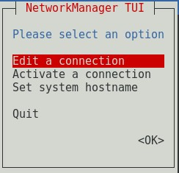

**3.1.4** Edit Wired connection 1 with Automatic IP configuration

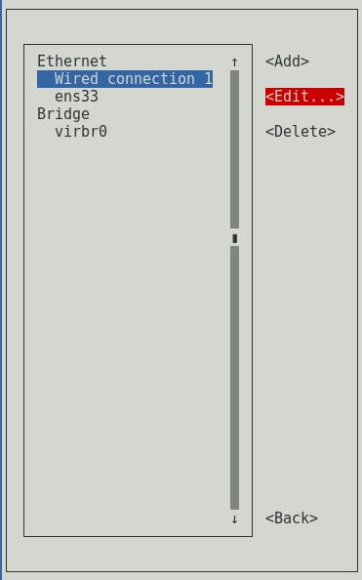

**3.1.5** Edit ens33 with Manual IPv4 configuration and go Back

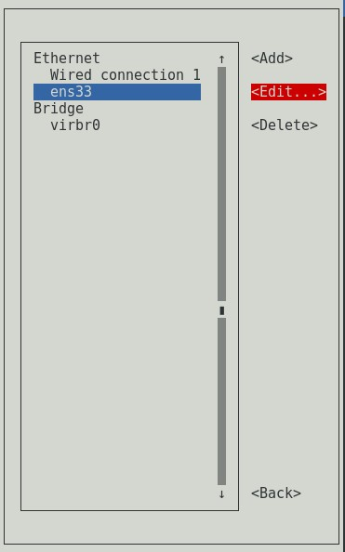

Figure 3.6: Edit ens33

**3.1.6** Select Set system hostname and change the hostname as preferred

Figure

3

.

9

:

Set system hostname

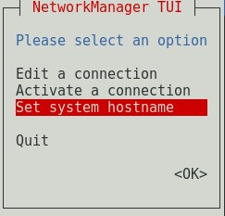

**3.1.7** Select Activate a connection and activate both network connections

Figure

3

.

12

:

Activate a connection

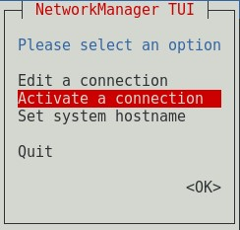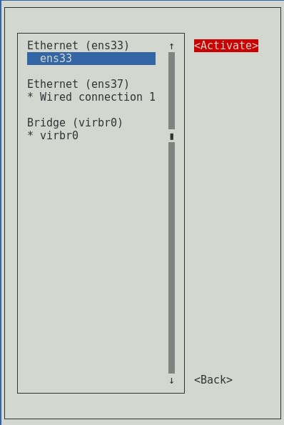

Figure 3.13: Activate ens33 connection

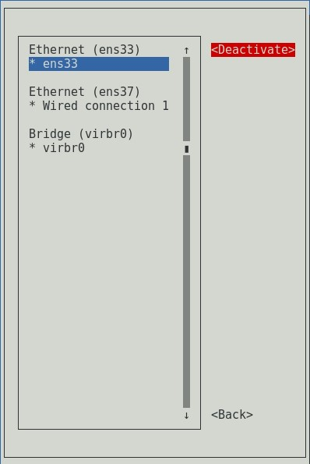

Figure 3.14: Go Back

**3.1.8** Click OK to exit from Network Manager TUI

Figure

3

.

15

:

OK to exit

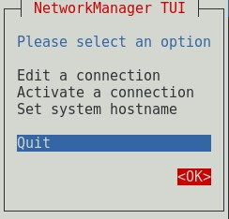

**3.1.9** Check network configuration using ifconfig



Figure 3.16: Check network details

**3.1.10** Open dhcpd file and add “DHCPDARGS=ens33” at the end of the file



Figure 3.17: Add network adapter details to DHCP file

**3.1.11** Check dhcpd configuration file



Figure 3.18: Check DHCP configuration file

**3.1.12** Copy the file to another destination. Click tab twice to show version number

Figure

3

.

19

:

Copy DHCP file to another location



**3.1.13** .co



Figure 3.20: Open DHCP configuration file to edit

**3.1.21** Check DHCP service status and start service



Figure 3.28: Check DHCP status

**3.1.22** Start DHCP service and enable DHCP service to start at the OS startup



Figure 3.29: Start DHCP service



Figure 3.30: Enable DHCP to run at the startup

**3.1.23** Check DHCP service status again

Figure

3

.

31

:

Check DHCP status



## Configure DHCP in Client machine

**3.2.1** Following same procedure as previous open Network Manager with nmtui and Edit connection to Automatic DHCP

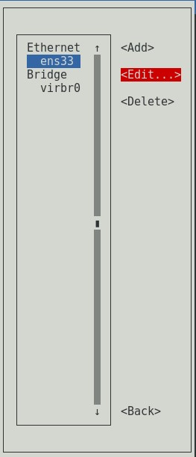

Figure 3.33: Edit Connection to Automatic DHCP

**3.2.2** Change hostname as preferred and activate the connection

Figure

3

.

35

:

Activate the connection

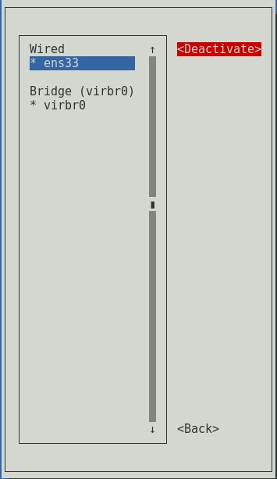

**3.2.3** Check received IP with ifconfig through DHCP server

Figure

3

.

36

:

Check network connection



# DNS Configuration